Assignment 1: Data Warehouse/Mart Design Approach (50%)
Student Name: Sumandeep
Leedbeckeet University

Table of Contents
1 Identification of data and defining requirements: 3
1.1 Data Dictionary of Dataset 3
2 Data warehouse/mart Architecture and Methodology: (1500) 5
2.1 Challenges in Data Warehousing 7
2.2 Data Warehousing Solution 8
3 Data warehouse/mart Design: 9
3.1 Star Schema Design 10
4 References 12

Identification of data and defining requirements:
Data warehousing essentially part of database management system in which various data and sets of data various varieties of large amount of data has been connected and interlinked with different location of the UK cities. So the stakeholder of department manager needs to investigate the various crimes reporting dataset which coming from different UK cities locations. The dataset consist of crimes in which different types of crimes has been happened at different areas, the nature of crime and location of crimes has been occurred and verified investigated to propose the resultant action.

Data Dictionary of Dataset
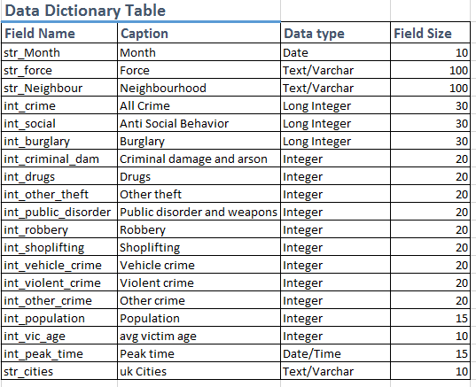
Figure 1: Dictionary table (Using Excel)
The above mentioned data dictionary has been created in Excel software, which is part of database and datasets, essentially excel tool has been widely used in data science and data analytics application.

(Giorgini, P., Rizzi, 2005) goal oriented approach for designing the data mart and data warehouse for police official manager in which needs to investigated the routing data from various location of the UK cities. If data warehouse fails to meet the police manager requirement, the reason is behind the requirement analysis does not meet the required data mart nature, the goal of Tropos methodology in which various perspective of data integration data management has been analyzed and extract from the data mining algorithm to reach the exact destination of information cell. The decision maker wants to investigate the crimes data from various central data mart location that fulfill the online processing goal, because directly connected with central database of police manager station. Mixed demand driven supply and demand approach (Kumar, M., Gosain Y., 2010) stakeholder driven requirement of this crime case studies connected with police manager, in data warehousing projection the method of agent goal decision information model support the late requirement of DW agent refers to stakeholder of criminal that support three data mart approaches organization modeling, decision modeling, information modeling development of crimes data warehousing projects followed by police officials.
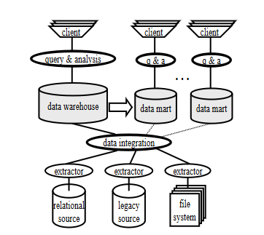
Figure 2: Data warehouse architecture

Data warehouse/mart Architecture and Methodology: (1500)
(Hendrawan, R.A., 2013) independent data mart tools for data analysis as standalone data application, since the various companies offer decision making support with the help of decision making database system in which various organization goals has been analyzed and predicted with the help of producing the goal oriented approach to deploy the data mart application, because data already there to use by using the central database system. The goal of data analysis needs data warehousing & mining approach with using the various online server offers verities of data mart and data warehousing facilities to the stakeholder of the organization. The architecture of data mart application based on two perspective including data and software, the way of data analysis in terms of short period of time and long period of time has been producing with the help of data mart pragmatic solution. With the implementation of standalone software to deliver independent data mart known as commonly data analysis tools package (Prakash, N., Prakash, D., 2017) agile data warehouse development by using the SCRUM incremental project which provides the data mart information with initial back log of user stories. The ad hoc experience driven approach has been analyzed including model driven approach which help for story writing relative more systematic approach that provides the story writing tasks services. The systematic three layer approach proposed to design the data warehouse system that based on inter relationship between the database cardinalities which helps to identifies the criteria, the model proposed to support the relative information tasking features selection information, extracted information present the analyzed way to predict the actual problem. Decision model proposed to derive the performance analysis (Prakash, N. Prakash 2018) issues in data warehousing engineering to support central role decision management that establish the decision makers to achieve the task which based on three decision system. The formulation of business policies making strategies enforce the business operations to achieve the software engineering solution by implementing the data mart approach to solves the specific type of standalone data warehouse. Data warehouse fragment the each layer of (Wang, Z. Li, Y., 2017) equipment maintenance decision support system based on data mart projection, equipment of maintenance support system to solves the business intelligence solution which support data analysis, decision making, data integration, data acquisition, data mining, practically analyzed and predict the ways of data warehousing system to proceed the maintenance support system of electronic, the development of efficient and energetic algorithm that mines the information to proceed the actual task. (Battaglia, A., 2011) QBX was using as case tool for designing and implementation of data mart resultant from close view of academic and industries. The design support the conceptual design, logical design and deployment of ROLAP data mart in the formation for star schema design including snow flake implementation used by various business user that explore the related knowledge of various level of abstraction, QBX support both forward and reverse engineering concept of data mart design. (Bargui, F, Feki, J., 2019) data mart design enhance the decision support system of data warehousing projection design, contribution of natural language based processing based on template requirement & design requirement specification algorithm process the decision making approach. Decision making ontology provides systematic decision making goals, the best approach considering by implementing the natural language based processing of data warehousing projection in order to achieve the data mart design of ETL generation. (Bargui, F., Ben 2016) semi-automatic data mart design and ETL generation which support the automatic data mart design still data warehousing projection facing various challenges and issues due to requirement analysis algorithm does not refine which does not produce the high quality results. The natural language based method to design data mart schemas, the concept of decision making process while making the structured natural language processing format. The support of requirement validation with respect of data source used in ETL process with the support of semi-automatic of conceptual data mart schemas directly map to data source. The mapping procedure contribution the description of ETL process, the proposed method illustrated with software prototype method by mean of empirical analysis recognized as top down method.

(Garcia-Molina, H., Labio, 1998) distributed and parallel computing issues by implementing the data warehousing projects. The data warehouse known as repository of data which extracted and integrated with heterogeneous and automatic distributed sources. The data warehousing has been used by various stakeholders of the organization for decision making purposes. The approach of data mining and decision support which extract the exact information in the large quantities of data warehouse system. The distributed and parallel computing process affected by the various computer network domain, in data warehousing projection source contains the raw data which needs to be integrated from relational database system including IMS, IDMS, and other legacy system of database system. The integration software transformation system arbitrary transform the sequence of relational project with select and join operation which merge data from several sources, remove duplication entries, eliminate other data scrubbing operation which add timestamps on meta data including complex aggregation computation. Query analysis software allows stakeholder to query the desired criminal record entries which happened on recent days. Data mart received replicated copies of data including local decision stakeholder authorities. Data warehousing maintenance required when the source data changed incorporate to materialize view. The incremental model evaluated the new raw data with support of with support of current view content changes.

Challenges in Data Warehousing
Various challenges exists in data warehousing projection (Garcia-Molina, H., Labio, 1998) due to processing of large amount of information, data contains in the form of multimedia, structured, semi structured, forms so there is need of ETL operation and OLAP operation to combines the certain task to process and extract the database. Relational database might be contains repeating values, detect the flat changes in the file which needs to restore and represent the information in actionable form. Sources data might be continue to changes with effect of various changes happened in the data transformation processing. The concept of computation processing system to maintain the centralized database system to execute the data from different sources and execute the multiple sources with multiple view. (Araque, F., Salguero, 2006) data warehousing algorithm to integrate temporal properties, most complex issues of data integration transform the interface with multiple sources including single data warehousing system the single information has been extracted to transform the information from the large verities of data warehousing, the elements of large data warehousing extracted the required information with the assistance of mining algorithm, that leads to extract the particular type of information form large quantities of database system. the objectives of large amounts of facets variable needed to integrate the phase of interested temporal problem, it is necessary to solves the problem by feeding the ETL extract transform of data into the required source and destination. This research present the data warehouse basis of temporal properties of the data source, liable on the extraction methodology, the possible data warehouse features examines the temporal features which depends on the data integration process and data extraction method. (Verma, H., 2013) data warehousing on cloud computing featuring the content management system offers by various universities in which everyday student engagement of data creation and data uploading method which essentially incorporate to data processing & data offloading method from cloud computing to source computing by using the internet service provider platform.

Data Warehousing Solution
Data warehousing over cloud computing in which recycle and reuse the data again through data upgradation processing method. The aim of cloud computing provides the interface of online data transformation and data extraction service mechanism, it solves the enterprise application which part of cloud computing platform. In these days cloud computing platform leading to storing, retrieving, processing services that enable the online method to view the data. (Bonchi, F., Giannotti, 2001) data mining algorithm works on by using the online web log method which extract the exact information by dealing the method of intelligent web caching service, the intelligent web caching service employing to predict the models of web requests by implementing the policy of web proxy server. two approaches has been served in which data mining approach which based on tree method, and other is LRU based technique method to hit the web designed to extract the web log data with data mining algorithm in order to obtain the outcome. (Chowdhury, Kumar, S., 2020) integrated proposed authentication algorithm designed to mine the large amount of information from data warehousing system, by using the end user navigation system. since the data warehouse optimize the database, with originate from diverse set of information, the organization incorporate leading in edge to process the diverse foundation data warehousing encompasses to process the large quantity of information leading to edge based technology. Data mart presenting the data warehousing system since the goal of solitary driven approach to optimize the performance which integrate the information, data mart operates parallel processing of data warehousing in safekeeping processing of database system. Data mining algorithm used by various system such as IBM SPSS Modeler, oracle data mining besides this python programming is essentially used to process the big data warehousing processing, rapid miner is one of the best data mining tool.

Data warehouse/mart Design:
(Adamson, C., 2012) dimensional model of star schema design based on fact table, star schema design was designed to implement this model by building up the data warehousing model. For the development of entity relationship diagram model for creating the database management system, deploying the database management system to integrate the various project. The first is involved to classify the entities in the data model to represent the number of categories in the system, second steps involves to identify the hierarchy that present in the database model. And the final steps involves to collapse the entities into sub categories and group of repeating entities. The number of alternative design depends on the various values of the repeating group entries which involves to present the database system. the flat schema, terrace schema, star schema design used to present the new type of snow flake schema the star cluster schema present the snow flake schema in which various entities and tables entries has been displayed to defined the overall functionality of the fact table. The number of tables should be restricted to avoid the table entries and overlap table entries from the other source of information. (Hanlin, Q., Xianzhen, J. 2012) the method of extract transform and load method in land to resource the star schema data warehouse. Data mart present the overall parallel processing of the distributive computing of data warehousing from different sources. The extract transform and load method used to load data from heterogeneous sources transform the data and also load the data into the data warehouse system. Data mining technique used to process the business intelligence application widely all over the globe to save the time and cost & build relationship computationally. To extract the criminal records from multiple cities of the UK it is mandatory to connect police official database connected centrally to connect the centralize information into the overall framework.

Star Schema Design
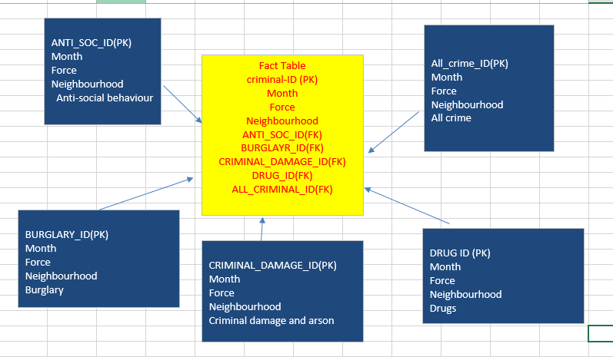
Figure 3: Star Schema Model Using Excel
The technology of ETL method has been extensively used by various data warehouse service provider to enhance the data analytics and extract service over the node. (Sidi, E., El 2016) the design process of effective data warehousing used to present the effective part of production database system. The small time interval considering the most important time interval to proceed the system of awareness. To present the KPI in the organization quickly need to minimize the query execution time. The development of star schema model provides the facility to use bitmap index based on ETL query execution time with data access time. (Zhu, J., Potti, N., 2017) query optimizer and query execution engine used to manage and organize the high performance complex analytic queries. The optimization time of execution processing system needs to visualize and organize the execution engine. The query execution strategy called lookahead information passing which executes on robust time frames to process the query in large amount of data warehousing framework. (Dehdouh, K., Boussaid, 2014) the arrival of columnar no SQL star schema means to evaluate the performance of the system during processing time of query on different technical choices various companies using big data by using the NOSQL framework by using the distributed computing system, NOSQL data warehousing recognize as CNSSB lets to make artificial data including DBMS and HIVE query language perform better compare to SQL and other system.

References

Giorgini, P., Rizzi, S. and Garzetti, M., 2005, November. Goal-oriented requirement analysis for data warehouse design. In Proceedings of the 8th ACM international workshop on Data warehousing and OLAP (pp. 47-56).

Kumar, M., Gosain, A. and Singh, Y., 2010. Stakeholders driven requirements engineering approach for data warehouse development. Journal of information processing systems, 6(3), pp.385-402.

Hendrawan, R.A., 2013. Developing Independent Data Mart and Analysis Tools as Standalone Application. ISICO 2013, 2013.

Prakash, N. and Prakash, D., 2017, July. Model-driven user stories for agile data warehouse development. In 2017 IEEE 19th Conference on Business Informatics (CBI) (Vol. 1, pp. 424-433). IEEE.

Prakash, N. and Prakash, D., 2018. Issues in Data Warehouse Requirements Engineering. In Data Warehouse Requirements Engineering (pp. 51-69). Springer, Singapore.

Wang, Z. and Li, Y., 2017, December. Equipment Maintenance Support Decision Method Research Based on Big Data. In International Conference on Geo-Spatial Knowledge and Intelligence (pp. 544-551). Springer, Singapore.

Battaglia, A., Golfarelli, M. and Rizzi, S., 2011, October. Qbx: a case tool for data mart design. In International Conference on Conceptual Modeling (pp. 358-363). Springer, Berlin, Heidelberg.

Bargui, F., Ben-Abdallah, H. and Feki, J., 2019. Enhancing the involvement of decision makers in data mart design. International Journal of Data Analysis Techniques and Strategies, 11(2), pp.148-175.

Bargui, F., Ben-Abdallah, H. and Feki, J., 2016. A natural language-based approach for a semi-automatic data mart design and ETL generation. Journal of Decision systems, 25(4), pp.309-344.

Garcia-Molina, H., Labio, W.J., Wiener, J.L. and Zhuge, Y., 1998. Distributed and Parallel Computing Issues in Data Warehousing (Invited Talk). In Proc. of the Tenth Annual ACM Symposium on Parallel Algorithms and Architectures (Vol. 10, No. 277651.277673).

Araque, F., Salguero, A., Delgado, C., Garví, E. and Samos, J., 2006. Algorithms for Integrating Temporal Properties of Data in Data Warehousing. In ICEIS (1) (pp. 193-199).

Verma, H., 2013. Data-warehousing on cloud computing. International Journal of Advanced Research in Computer Engineering & Technology (IJARCET), 2(2), pp.411-416.

Bonchi, F., Giannotti, F., Gozzi, C., Manco, G., Nanni, M., Pedreschi, D., Renso, C. and Ruggieri, S., 2001. Web log data warehousing and mining for intelligent web caching. Data & Knowledge Engineering, 39(2), pp.165-189.

Chowdhury, R. and Kumar, S., 2020, March. Integration of Proposed Authentication Algorithm for End User Data Navigation in Data Warehouse. In Proceedings of the International Conference on Innovative Computing & Communications (ICICC).

Adamson, C., 2012. Mastering data warehouse aggregates: solutions for star schema performance. John Wiley & Sons.

Hanlin, Q., Xianzhen, J. and Xianrong, Z., 2012, October. Research on extract, transform and load (ETL) in land and resources star schema data warehouse. In 2012 Fifth International Symposium on Computational Intelligence and Design (Vol. 1, pp. 120-123). IEEE.

Sidi, E., El, M. and Amin, E., 2016. Star schema advantages on data warehouse: using bitmap index and partitioned fact tables. International Journal of Computer Applications, 134(13), pp.11-13.

Zhu, J., Potti, N., Saurabh, S. and Patel, J.M., 2017. Looking ahead makes query plans robust: Making the initial case with in-memory star schema data warehouse workloads. Proceedings of the VLDB Endowment, 10(8), pp.889-900.

Dehdouh, K., Boussaid, O. and Bentayeb, F., 2014, September. Columnar nosql star schema benchmark. In International Conference on Model and Data Engineering (pp. 281-288). Springer, Cham.

